# How To Increase Sales By Understanding Your Buyer’s Journey

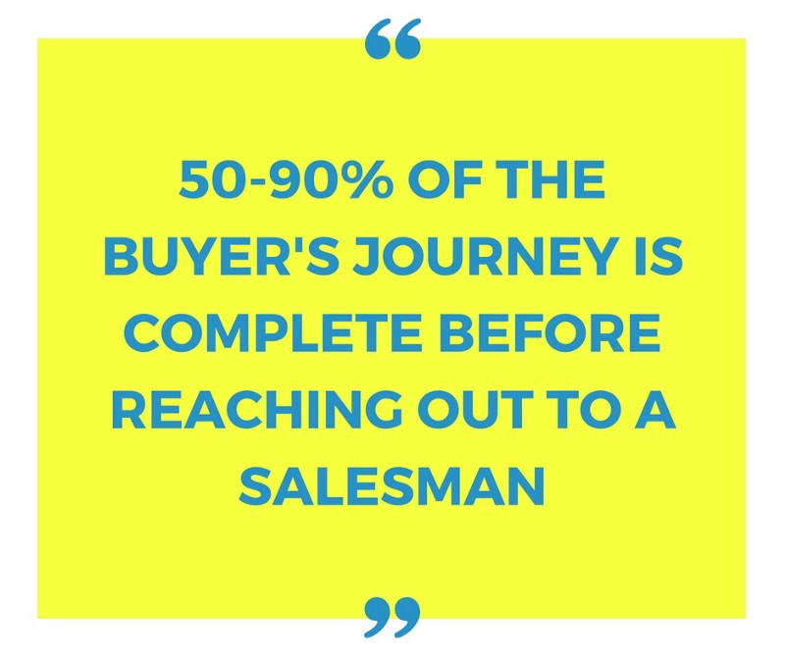

What if I told you that all buyers go on a journey before they become a paying customers?

Would you like to know what that journey looks like?

Better yet, what if you were able to find them at the very beginning of their journey and make sure the end of the yellow brick road leads to you?

**How you could take them by the hand before they even know who you are, or what you offer…and guide them into doing business with you. Instead of your competitors.**

That’s the power of understanding your buyer’s journey.

#### **Here’s the problem:**

Most business aren’t talking to their prospects until they are already two-thirds of the way through their journey…

***Imagine staying two big steps ahead of your competition.***

Becoming the trusted, go-to expert in your industry before customers are even aware that your competitors exist.

**That would be a HUGE advantage, wouldn’t you agree?**

When you create a framework within your marketing that matches the buyer’s journey you have the power to:

* Create more leads
* Convert more leads into customers
* Increasing your share of the marketplace

#### *Here’s What Most Companies Are Missing…*

Buyers go through three stages:

1. Awareness
2. Consideration
3. Decision/Purchase

The problem with most marketing efforts is that they are only talking to prospects at one stage of the buying process, the last stage.

You see, they miss the two stages buyers must go through before they can even get to that point.

So, I have good news and bad news…

The good news is when you understand the process that takes your customers from the ‘Awareness’ stage through the ‘Decision/Purchase’ stage you can create a system that guides them through the process.

**And it can have a big impact on your business.**

The bad news is if your competition is talking to prospects early in the process, and you’re not, they are leading your potential customers into the doors of their business.

***But don’t worry!***

If this is the case, I’ll show you how to take your prospects back and turn them into your clients.

Let’s go over each stage of the buyer’s journey to discover how to improve your marketing and grow your business.

### **Stage One: Awareness**

The journey begins here, the ‘awareness’ stage.

At this point your prospects either:

1. Are not sure of their problem specifically, but know something is not right. They need help identifying the problem they’re experiencing in order to find a solution.
2. They do not realize that they have a problem, but would greatly benefit from the solution you offer. These people need help becoming aware of the problem they have, the issue you provide a solution to.

**When people are at this stage you cannot sell to them directly. You have to educate them first.**

How do educate them?

Provide informational content that helps them identify or gain clarity on the problem they’re experiencing.

*It’s important your content does not come off in a ‘salesy’ way or they will discredit you right away because it will seem like you’re just trying to sell them something. And they’re not at that stage yet.*

People love to buy, but don’t like to be sold.

So your content here is designed to:

* **Help them discover their problem**
* **Get to the next stage on their own terms**

By doing so, you establish your company as the authority in your industry and the go-to resource because you helped them at the beginning of the sales process by simply providing useful information.

So what information should your content include to talk to prospects at this phase?

Consider the questions people may be asking when at this phase…

*Start by answering this question: What problem do you solve?*

Provide content that answers this question to give people clarity on the problem they are facing, even if they aren’t aware of it yet.

Here’s an example:

A marketing agency that specializes in Pay-Per-Click(PPC) advertising and provides PPC Management services to local businesses would first need to identify what questions their prospects at this stage may have.

They are probably asking broad questions such as:

* How can I generate leads for my business online?
* How can I get more people to my website?
* Does advertising online work for local businesses?

So to reach people at this stage they would need to provide content that answers these questions.

They could create content titled:

* How any small business can generate leads online
* 3 ways to get more people to your website
* How local businesses can benefit from online advertising

By creating ‘How To’ style content that answers the questions your prospects are asking you can guide them to the next stage in their journey.

But before going on to the next stage there’s another audience that needs to be addressed: The people who aren’t aware they have a problem but could benefit from the solution you provide.

For this audience your content needs to tell the ‘What’ of your solution.

**What problem you solve.** Or what they have to lose by not learning more about solving this problem. **The cost of inaction.**

For the marketing agency in our example, they could create content that answers the ‘What’ titled:

* Why every small business should be advertising online
* Could online advertising take your business to the next level?
* Are your competitors getting YOUR customers because you’re not marketing online?

*You are essentially generating demand for your solution, which requires a different approach to fulfilling demand.*

Here’s what I mean…

Because you are providing answers that people aren’t actively searching for, you will need to take the content to them (or they will never find it). Facebook ads is one way to do this.

This is different than your ‘How To’ content that provides an answer to questions people are searching for, which would perform well on Google or similar search platforms.

The best ways to provide content at this stage is through:

* Blog posts
* Reports
* Ebooks
* Whitepapers
* Videos

But you don’t have to choose only one of these. People consume content in different ways.

For example, I would prefer to read a blog posts instead of watching a video with the same content. But many people prefer the opposite and would watch a video instead of reading a blog posts.

By having different ways for people to consume your content, the larger and more diverse audience you will be able to reach.

Now let’s look at the next stage…

### **Stage Two: Consideration**

The next step on the buyer’s journey that your prospect goes through is the ‘Consideration’ stage.

In the ‘Awareness’ stage you demonstrate that you understand the problem your buyer is facing or help them realize they have a problem worth solving.

*By doing this, you begin to establish yourself as the*go-to expert.

Now that your prospect is aware of the problem, you need content that educates on the solution.

It’s important to keep in mind that you are still not selling at this point, you’re simply guiding them to discovering a solution to their problem (which you happen to provide!)

Not selling at these first two stages may seem counter-intuitive. That’s because most marketing and sales efforts are designed for the buyers in the final stage of the buyer’s journey.

When you help buyers through this process, you’re making the job of selling much easier…

When it comes time to make a purchasing decision they’ve already decided on the solution (with your help)

And positioned yourself as the expert, while gaining their trust in the process.

Essentially, they’re already sold!

In the ‘Awareness’ stage your content was problem focused. It answered questions your prospects were asking with about how to solve their problem, and what problem your solution solves.

**Now you’ll need to answer the ‘Why’…**

Why the solution you provide is the answer to solving their problem.

What’s the best way to do this?**Focus on the benefits of your solution.**

Let’s look at our previous example to demonstrate how this could be done:

We will assume the marketing agency created a blog post for people at the awareness stage titled, “How Any Local Business Can Benefit From Online Advertising” to answer the question, “Does advertising online work for local businesses?”

Since their prospects are now problem aware, they may now be searching phrases such as:

* Best online advertising channel for local businesses
* Ways local businesses can generate leads online
* Local business online advertising examples

The content they would need for this stage would need to answer the question of why the service they provide, PPC advertising, is the solution for local businesses.

They could do this by creating content such as:

* Why PPC is the best advertising model for local businesses
* 5 ways local businesses can benefit from PPC advertising
* [Case Study] How this local business doubled it’s leads using PPC ads

**Remember, the goal here is to answer the question of why what you offer is the best solution to the problem they are facing.**

A few of the best ways to provide content at this stage is through:

* Comparison Whitepapers
* Expert Guides
* Videos
* Webinars
* Blog Posts

At this point we’ve helped people clarify their problem, or made them aware of the problem they didn’t know they had, in the awareness stage. And explained why the product or service we provide is the solution to that problem in the consideration stage.

Note: It’s important to really focus on the solution to the problem at this stage. Yes it will be a solution that you offer, but you’re not focusing on why you should be the one that provides that solution to them yet. You’re helping them discover the solution is the answer.

Now we move on to the final stage…

### **Stage Three: Decision/Purchase**

They are now getting close to the end of the buyer’s journey and will be making a decision to purchase soon.

Many businesses only market to, or have content that relates to, people at this stage. Which means prospects before reaching this part of their journey either:

* Never become fully aware of the problem they are experiencing or gain clarity on the issue, or…
* A competitor offered the answers they needed to progress through their journey, and by doing so, positioned themselves as the go-to resource and industry expert

Depending on your marketing and content strategy…

*You’re either two steps ahead of your competition…or two steps behind.*

By the time they have made it to this stage they are already sold on a solution that they believe will solve their problem and are now comparing features, deals, offers, products and companies.

Now is when your content should persuade the prospect that not only is the solution they have decided on the best choice, but also you’re the best option to provide it to them.

*Simply put, they need to be sold on you.*

The best way to do this is to provide content that shows how the value they will receive outweighs the cost…

How the benefit of what you offer is far greater than the price.

#### *Pro-Tip To Stand Out From The Competition:*

Dig deeper into what solving that problem for your buyer really means to them.

**What’s the ‘benefit of the benefit’ that solving the problem gives to the customer?**

Discover this by asking questions.

Let’s demonstrate this with the marketing agency example:

Problem: Needs to generate leads online.

Benefit of solving problem: Increased revenue and consistent leads.

The benefit of the benefit (increased revenue and consistent leads) could mean:

* The ability to expand and open up another location
* Peace-of-mind for the owner
* Saving a struggling business by helping them adapt with the changes in marketing and technology

**To do this you need to really understand your customer.** If you’ve been in business for some time, your customer has probably told you the real benefit they were able to get from your product or service. Were you listening to pick up on it?

**You can really set yourself apart from your competition by doing this —**

This is how you can go from being an option to THE option.

Another thing that can make a big difference is to keep in mind that **people are triggered to buy for different reasons…**

Some people need to see social proof that others, like them, have benefitted from your solution.

Your technical prospects will need to know the specs.

The hands-on person may need a trial version to test out if your business offers it.

A few of the best pieces of content for this stage are:

* Case studies
* Testimonials
* Product Demos
* Product Literature
* Company Comparisons
* Product Comparisons
* Testimonials
* Reviews

The more content you offer that covers and pushes these ‘hot buttons,’ the more people you will persuade to become a customer.

### **Conclusion**

The key takeaway here is to understand that your prospects are at different stages of the buyer’s journey.

**A successful marketing plan needs to have content for people at each stage.**

Map out your buyer’s journey now. The insight you will gain is enormously valuable!

You will be able to:

* **Get more leads by getting to your prospects early**
* Establish your expertise and become the go-to resource in your industry
* **Make sales EASIER because you’ve helped the buyer come to their own decision**(people love to buy, but don’t like to be sold)
* Convert more prospects into buyers
* **Create value throughout so you’re not competing on price**
* Speed up the buying process by guiding your customer through the stages of their journey

Start by understanding how your prospects become customers, then create content that speaks to them at each stage. **This is probably be the best investment you can make in your business today.**

And don’t be surprised if this isn’t the easiest way to get more leads, convert more prospects to customers, and make the competition irrelevant.

https://blog.markgrowth.com/how-to-get-more-leads-easier-sales-and-dominate-your-market-by-staying-two-steps-ahead-of-your-75c1a86664e2